**Red John** has committed another murder. But this time, he doesn’t leave a red smiley behind. What he leaves behind is a puzzle for **Patrick Jane** to solve. He also texts **Teresa Lisbon** that if Patrick is successful, he will turn himself in. The puzzle begins as follows.

There is a wall of size CxN in the victim’s house where C is the 1st *composite*number. The victim also has an infinite supply of bricks of size Cx1 and 1xC in her house. There is a hidden safe which can only be opened by a particular configuration of bricks on the wall. In every configuration, the wall has to be completely covered using the bricks. There is a phone number written on a note in the safe which is of utmost importance in the murder case. **Gale Bertram**wants to know the total number of ways in which the bricks can be arranged on the wall so that a new configuration arises every time. He calls it M. Since **Red John** is back after a long time, he has also gained a masters degree in Mathematics from a reputed university. So, he wants Patrick to calculate the number of prime numbers (say P) up to M (i.e. <= M). If Patrick calculates P, Teresa should call **Red John** on the phone number from the safe and he will surrender if Patrick tells him the correct answer. Otherwise, Teresa will get another murder call after a week.

You are required to help Patrick correctly solve the puzzle.

**Sample Input**  
The first line of input will contain an integer T followed by T lines each containing an integer N.

**Sample Output**  
Print exactly one line of output for each test case. The output should contain the number P.

**Constraints**  
1<=T<=20  
1<=N<=40

**Sample Input**

2

1

7

**Sample Output**

0

3

**Explanation**

For N = 1, the brick can be laid in 1 format only



The number of primes <= 1 is 0 and hence the answer.

For N = 7, one of the ways in which we can lay the bricks is

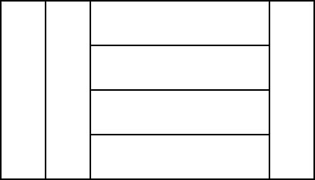

There are 5 ways of arranging the bricks for N = 7 and there are 3 primes <= 5 and hence the answer 3.